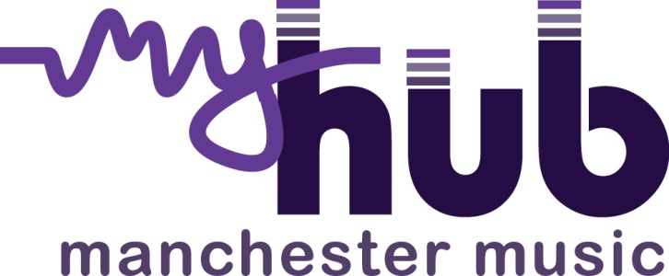

Manchester Music Hub – “Thinking Differently”

MyHub have set aside £20,000 to support the development of special projects in Secondary and SEND schools across Manchester. The projects must take place between April 2017and April 2018.

We are inviting Secondary or SEND schools to apply to our investment fund to deliver innovative projects that engage large numbers of students in regular musical activities during the year. MyHub wants schools inspire and engage pupils through active music making.

The Fund will:
- extend relationships between schools and MyHub
- support and celebrate good and innovative practice in schools
- increase the numbers of pupils engaging with music
- provide new pathways to music making
- improve instrumental progression routes for targeted groups of students
- Increase partnership between schools and/or creative music organisations in Manchester
- Promote the project and its outcomes through the MyHub web site
What does the fund provide?
- Grants of up to £2,500, per school, to deliver their project.
- Advice on how to apply and build an innovative project
- Support in realising the outcomes of the project

What we are looking to fund?
We are looking for project applications from schools within Manchester that have the power to innovate and engage many students in regular music making.
Schools willing to commit some of their own resources in cash and/or in kind
There is no stipulation on what kind of music and how this is delivered, but it must be a regular engagement with a consistent cohort of young people.
Schools are encouraged to work with other schools or cultural partners in Manchester. A list of these partners with their contact details can be found on our web site.
Schools are asked to address MyHub quality criteria which can be found on our web site under the Schools pages
www.myhub.org.uk

What we are unable to support
- We are not expecting the grant to be used solely to support gifted and talented students.
- The fund should not be used exclusively to purchase equipment or resources (a maximum of 10% of this fund can be allocated to resources and equipment).
- A single event – whilst showcasing and performance may well be a dimension of your approach, we are expecting proposals to demonstrate regular and sustained access to musical opportunities over time.

Timescale
- Application forms can be accessed on the “schools” section of MyHub web site from the beginning of January 2017 in the Schools pages.
www.myhub.org.uk

- Your application should include an outline of the project idea and the students that you are expecting to work with. Your application should be signed off by your Head Teacher.

- Applications should be submitted to Lindsay Thomas of One Education Music by noon on February 6th 2017
Lindsay.thomas@oneeducation.co.uk

- Decisions will be made by March 1st^{st} 2017. The team assessing the applications will be made up of Lindsay Thomas One Education Music, Sue Harrison Chair of MyHub, Debra King, Director Brighter Sound and Nick Ponsillo, Director of the Phillip Barker Charity Creative Learning centre Chester University, both are board members of MyHub.

- Discussions with successful schools will take place between March 6th – March 17th to the discuss project and its potential outcomes

- Projects should begin in April 2017

- Payment will be released to successful schools in 2 instalments in April 2017 and September 2017. The second payment in September 2017 will be subject to the submission of a simple impact statement/report. 10% of the agreed amount will be retained until the final evaluation of the project has been submitted. All other funding must be confirmed before the grant is released.
Specific eligibility criteria
- Successful schools must be prepared to share their learning and outcomes of their project with other schools through the Secondary/SEND Music Network. This may be in the form of presentations, case studies or video evidence.

